# /abbreviations

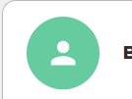

Change icon background to rgb(65, 92, 152) or rgb(88, 88, 88)

Show tiles in 3 columns

/with-progress-bar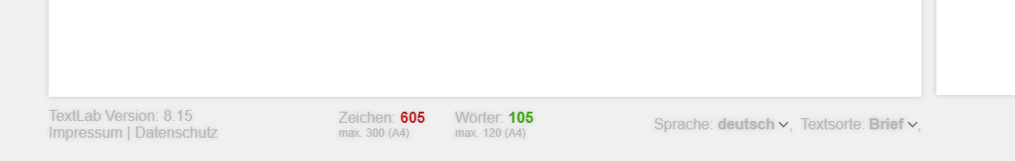

Take out shade – looks blurry

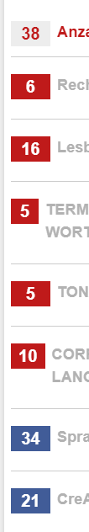

Number areas need to always have the same size

# User-profile/user



Change background to rgb(88, 88, 88)

NO allcaps: USERNAME > Username etc.

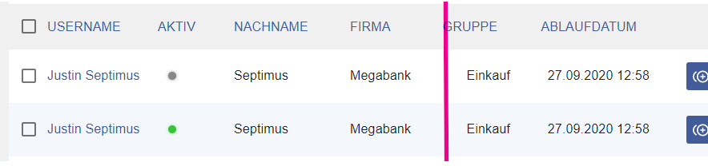

Align “Gruppe” and “Einkauf”

No allcaps in title line.

Dropdown:

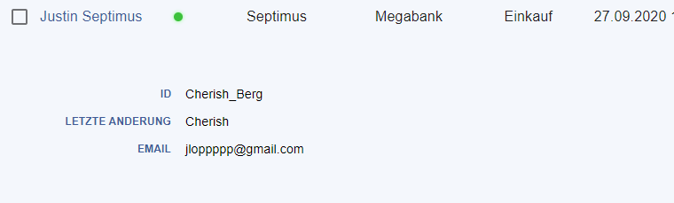

Try to use layout of archive dropdown

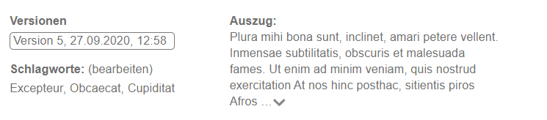

# user-profile/user/update/0

also use grey backgrounds for the section titles

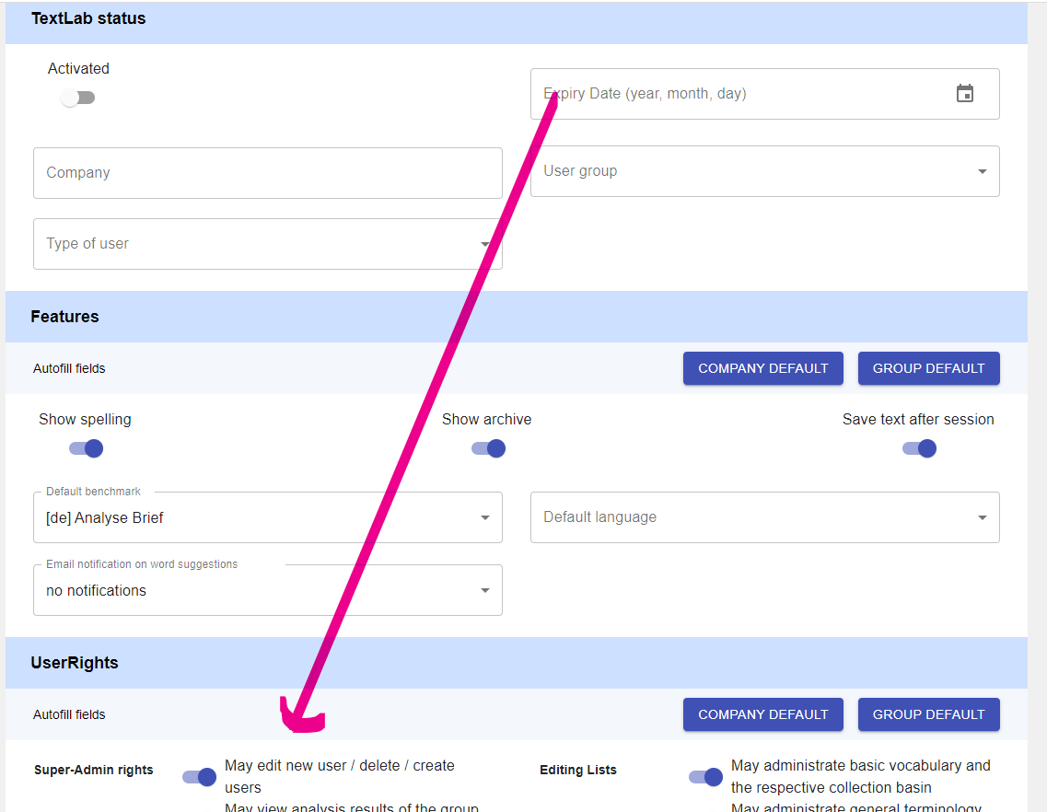

Move “expiry date” to section user rights (because we decided there will be a company default option for it)

# /archive

In dropdown:

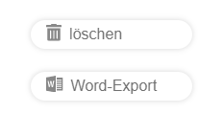

Create blue buttons in your style, like in user admin dropdown

Add a button: “change analysis name”

Filter dropdown:

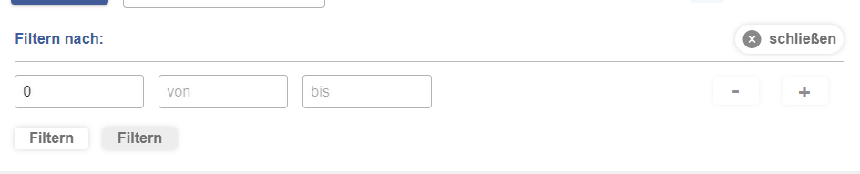

Use same filter fields as in admin area:

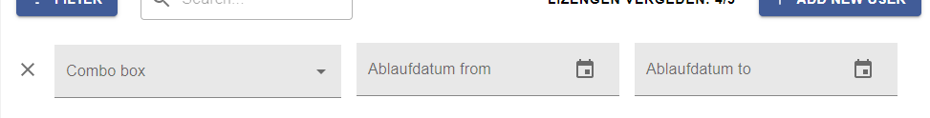

Filter by

text type (letter, web text, technical text)

date (from…to)

selection options:  
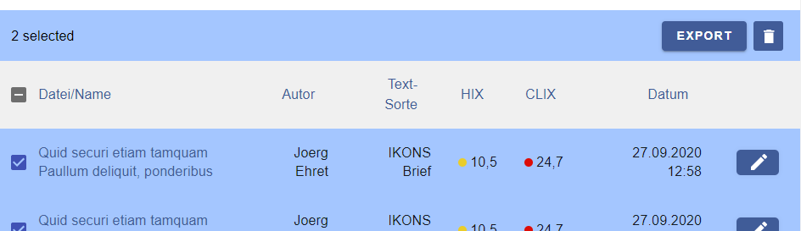

* Export text (to Word/Plain Text)
* Export evaluation data (to Excel/CSV)
* Delete selection
* Move selection to different folder (folder selection: Ordner 1, Ordner 2, Ordner 3)